ECONOMIC DATA WAREHOUSE ANALYTICS REPORT
Macroeconomic Stability & Risk Intelligence Across Emerging Economies (2005–2023)
1. Executive Summary
This project builds a multi-source economic data warehouse integrating macroeconomic indicators from the World Bank and IMF into a unified analytics-ready dataset.
The system transforms raw economic indicators into a structured model containing:
- GDP growth
- Inflation
- Unemployment
- Current account balance
- Government debt
- Composite economic health metrics:
  - Economic Health Score
  - Stability Score
  - Risk Classification
Key Outcome
The analysis reveals persistent structural vulnerabilities across emerging economies (Brazil, India, Kenya, Nigeria, South Africa), characterized by:
- High macroeconomic volatility
- Chronic fiscal and external imbalances
- Elevated unemployment pressure (especially South Africa)
- Frequent inflation shocks (notably Kenya and Nigeria)
Despite intermittent growth periods, all economies remain classified as HIGH RISK over the full period, indicating structural rather than cyclical instability.
2. Project Objectives
Primary Objective
To design a data warehouse pipeline (Bronze - Silver - Gold - Analytics) that consolidates global macroeconomic indicators into a unified analytical system for risk and performance assessment.
Specific Objectives
- Integrate multi-source economic datasets (World Bank + IMF)
- Standardize indicators across countries and years (2005–2023)
- Build a unified analytics layer for time-series economic comparison
- Develop interpretable economic health and stability scores
- Generate exportable datasets for visualization and reporting
3. Data Architecture Overview
Bronze Layer (Raw Data)
- Separate tables per indicator:
  - GDP growth
  - Inflation
  - Unemployment
  - Current account
  - Government debt (IMF)
- Wide format (year columns 2005-2024)
- No transformation except ingestion
Silver Layer (Standardized Model)
- Long format transformation:
country | year | indicator | value
Gold Layer (Business Logic Layer)
- Aggregated economic metrics:
  - Economic Health Score
  - Stability Score
  - Risk Category
  - Binary flags (strong economy / stress)
Analytics Layer
- Final analytical model:
country-year macroeconomic panel dataset
- Used for:
  - Trend analysis
  - Risk profiling
  - Visualization dashboards
  - CSV exports
4. Key Analytical Dimensions
4.1 Economic Health Score
Composite index derived from:
- GDP growth (+)
- Inflation stability (−)
- Unemployment (−)
- External balance (current account)
- Debt burden (−)
Interpretation:
- Higher score = stronger macroeconomic fundamentals
- Lower score = structural fragility
4.2 Stability Score
Measures volatility and consistency of macro indicators.
- Penalizes:
  - Inflation spikes
  - GDP contractions
  - Debt accumulation
Used to identify macroeconomic resilience.
4.3 Risk Classification
Category | Meaning
LOW RISK | Stable macro fundamentals
MODERATE RISK | Mixed signals
HIGH RISK | Structural instability
Result:
All countries in dataset are classified as HIGH RISK across most years, indicating systemic vulnerabilities in emerging economies.
5. Key Insights (Country-Level)
🇧🇷 Brazil
Observations:
- Strong GDP growth pre-2010 (peaking ~7.5%)
- Severe recession in 2015–2016
- Rising government debt after 2010
- Inflation volatility post-2015
Insight:
Brazil exhibits a cyclical economy with structural fiscal pressure, especially post-commodity boom.
Visualization ideas:
- GDP growth vs debt line chart
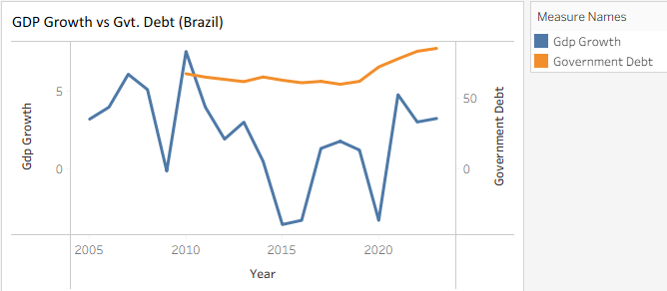
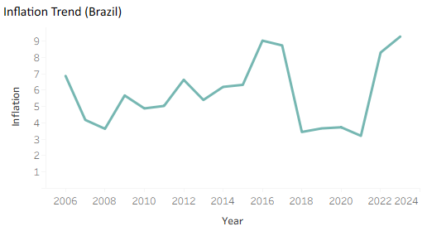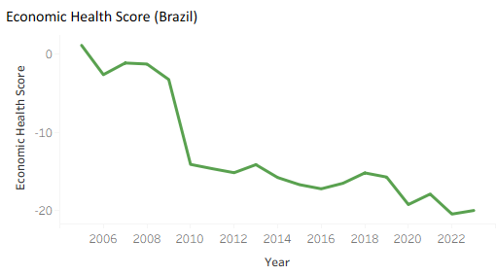

🇮🇳 India
Observations:
- Strong long-term growth (6-9%)
- Inflation spikes (2010-2013)
- Improved stability post-2015
- COVID shock in 2020 followed by rapid recovery
Insight:
India shows growth resilience with inflation sensitivity, but improving macro stability over time.
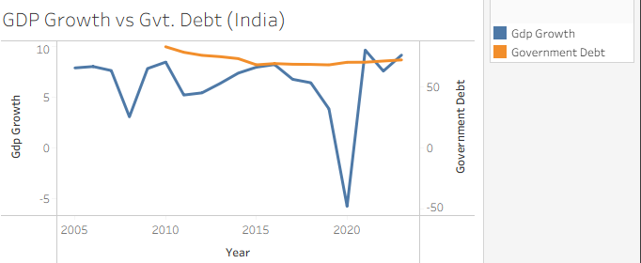
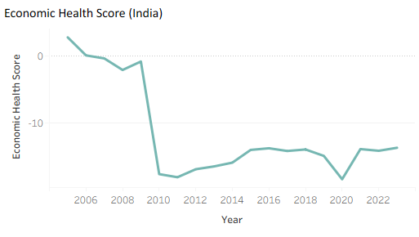
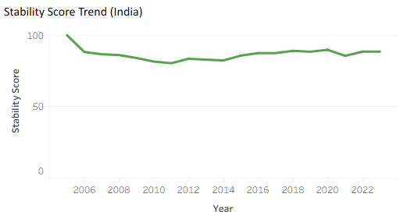
🇰🇪 Kenya
Observations:
- High inflation volatility (peak ~26% in 2009)
- Moderate GDP growth (3–6%)
- Persistent fiscal deficits
- Low unemployment data stability issues
Insight:
Kenya demonstrates inflation-driven instability and external imbalance risk.
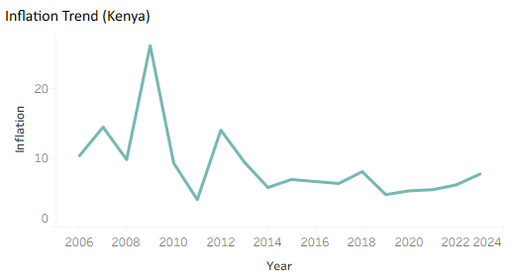
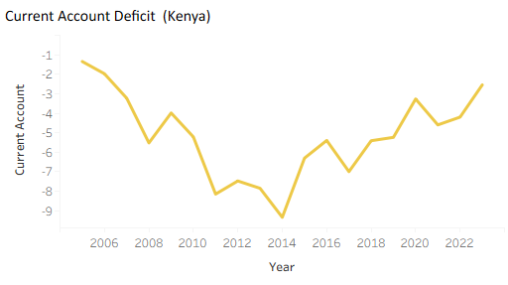
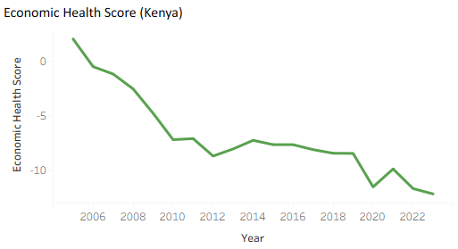
🇳🇬 Nigeria
Observations:
- Oil-driven volatility in GDP and external balance
- High inflation (peaking ~18%)
- Weak unemployment stability
- Frequent macro shocks
Insight:
Nigeria is a resource-dependent economy with structural inflation and fiscal instability.
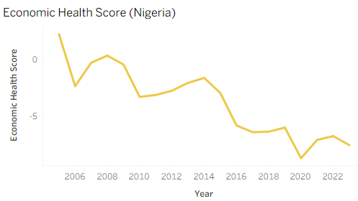
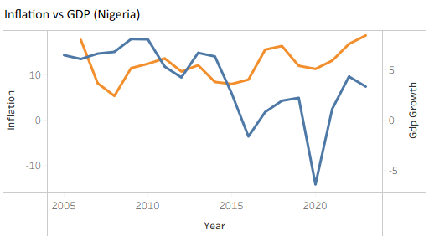
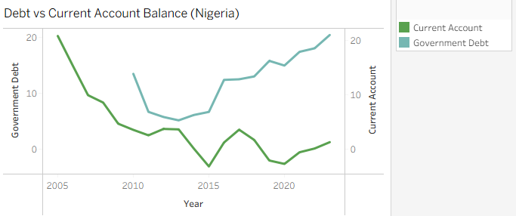
🇿🇦 South Africa
Observations:
- Persistent high unemployment (22% - 34%)
- Low GDP growth (<3% most years)
- Rising debt and fiscal strain
- Chronic economic stagnation
Insight:
South Africa shows structural unemployment crisis and low growth trap.
Visualization ideas:
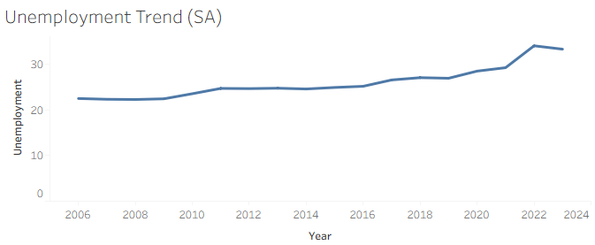
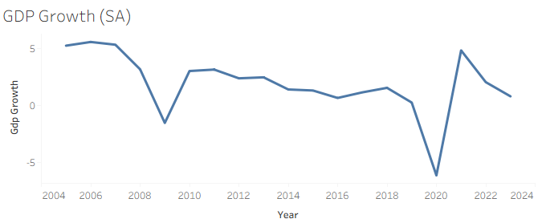
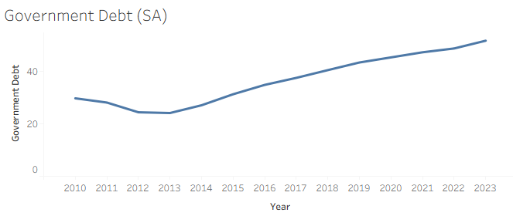
6. Cross-Country Comparative Insights
6.1 GDP Growth Comparison
- India: strongest sustained growth
- Brazil & Nigeria: volatile cyclical growth
- South Africa: weakest growth trajectory
6.2 Inflation Volatility Ranking
- Kenya (highest volatility)
- Nigeria
- Brazil
- India
- South Africa
6.3 Unemployment Pressure
- South Africa >> highest structural unemployment
- Kenya & Nigeria moderate
- India relatively stable low unemployment (historically)
6.4 Debt Burden Trend
- Rising across all countries post-2010
- Brazil and South Africa show strongest fiscal pressure
7. Suggested Dashboard Visualizations
You can build these in Power BI / Tableau / Streamlit:
Macro Overview Dashboard
- GDP growth trend (all countries)
- Inflation comparison line chart
- Unemployment heatmap
Risk Intelligence Dashboard
- Risk category distribution
- Economic health score ranking
- Stability score trends
Country Deep Dive Page
For each country:
- GDP vs inflation dual-axis
- Debt vs current account
- Risk score trend over time
Volatility Dashboard
- Standard deviation of GDP growth
- Inflation volatility index
- Economic shock detection (2008, 2020)
8. Key Findings
1. Structural Risk Dominates
All countries show persistent HIGH-RISK classification - not cyclical but structural.
2. Inflation is the Primary Instability Driver
Especially in Kenya and Nigeria.
3. South Africa is a Labor Market Crisis Economy
Unemployment is the strongest negative structural indicator.
4. India is the Most Resilient Economy
Strong growth offsets inflation and debt pressures.
5. Post-2010 Debt Expansion is Universal
All economies show fiscal expansion pressures.
9. Recommendations
Policy-Level Insights
- Strengthen inflation targeting frameworks (Kenya, Nigeria)
- Diversify fiscal revenue bases (Brazil, Nigeria)
- Structural labor reforms (South Africa)
- Improve external balance management (all countries)
- Sustain productivity-driven growth (India model)
10. Conclusion
This project successfully builds a macro-financial intelligence system that transforms raw global economic data into a structured analytical warehouse.
It enables:
- Country risk profiling
- Economic trend monitoring
- Policy-level insights
- Comparative macroeconomic analysis

